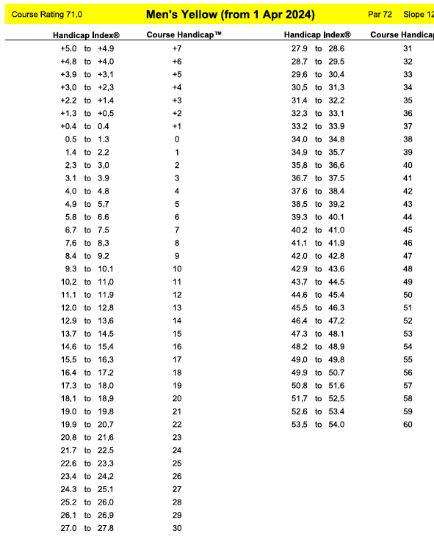
Kilworth Springs Slope Index

